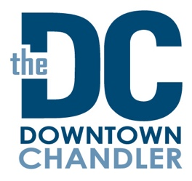
Downtown Stakeholders Meeting
Tuesday, April 12, 2022
3 p.m.
Pedal Haus Brewery
Agenda:
1.Welcome & Introductions, Megan Schmidt, DCCP Vice Chair

2.Downtown Update - Mary Murphy-Bessler, Executive Director
- Annual Celebration – May 18, 2022 – 3pm – The Perch

3.Special Events – Samantha Jackson, Operations Manager
- Jazz Festival Wrap-up
- Your Bacon Me Crazy Brunch Crawl
- Summer Events

5.Downtown Redevelopment Update - John Owens, City of Chandler
7.Downtown Police Update - Sergeant Chris Nevin, Bike Patrol

8. Announcements/Comments/Concerns

