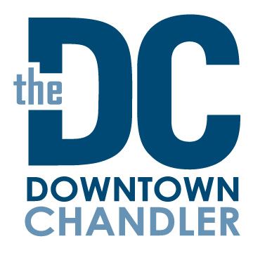

Stakeholders Meeting
June 14, 2022
Agenda

Welcome – Introductions/announcements

- July 4th Festivities
- Mary /John Overview of event
- Mary – Patriotic Holiday Décor
- Jess – Promotions

- Channel Your Chill – Jess

- Events Update – Mary
- July 4th Spectacular
- July 23rd – Annual Ice Bath Challenge 8am-noon – Boston Parking lot
DCCP tentative Event Schedule:
- Oct. 1 – Tentative – Downtown Chandler Octoberfest/ DCCP, Pedal Haus Brewery and SanTan Brewery, Dr. AJ Chandler West 3pm-11pm
- Nov. 26 – Small Business Saturday 1-4pm
- Sugarland – Nov. 26 – January 2nd
- Sippin Santa’s – December 10th
- Fine Arts and Wine Festival – February 17,18,19 (President’s Day weekend)
- Your Bacon Me Crazy Brunch Crawl – April 22nd

- Downtown Redevelopment Update – John Owens
- Summer Construction Project Update

Closing Announcements

Next meeting: August 9th 3pm

