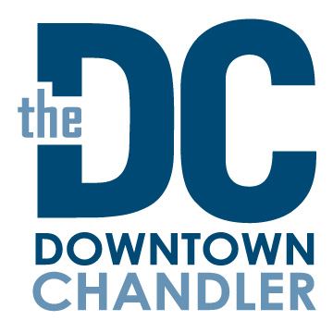

Stakeholders Meeting
August 9, 2022
The Uncommon

Agenda

- Welcome – Introductions/announcements Megan Schmidt, DCCP Chair
Attendees

- The Uncommon update/about Sherene Robinson, The Uncommon

- Oktoberfest Update Chris Purcell, Pedal Haus
Jamie Hoffman, SanTan Brewing Co.

- Safety Update Sgt. Chris Nevin, Bike Patrol Team

- Chandler Performing Arts Season Michelle Mac Lennan, Cultural Arts Manager

- Special Events in Downtown Hermelinda Llamas, City of Chandler Special Events

- DCCP Update Mary Murphy-Bessler, Executive Director
Jess Walrath, Marketing and Communications

- Redevelopment Update John Owens, Downtown Redevelopment Manager

- Adjourn Next Stakeholders Meeting October 11, 2022

