Interested in running an ad in our 2023 Guidebook?

What’s new? We are adding a QR code to the front of our Guidebook directing viewers to our digital guidebook (https://nashvilledowntown.com/digital-guidebook). This page has all businesses downtown and is categorized so viewers can easily search. We are offering digital ad space that will be featured on these pages. See below for rates/what the ad will look like on our website:

Printed Guidebook:

Half Page: $500
Full Page: $900
Inside Front/Inside Back Cover: $1,500
Back Cover: $1,800

Printed + Digital (nashvilledowntown.com):
(QR Code from Guidebook will direct here as well)

Half Page + Digital: $1,500
Full Page + Digital: $1,900
Inside Front/Inside Back Cover + Digital: $2,500
Back Cover: $1,800 + Digital: 2,800

See digital ad example HERE:
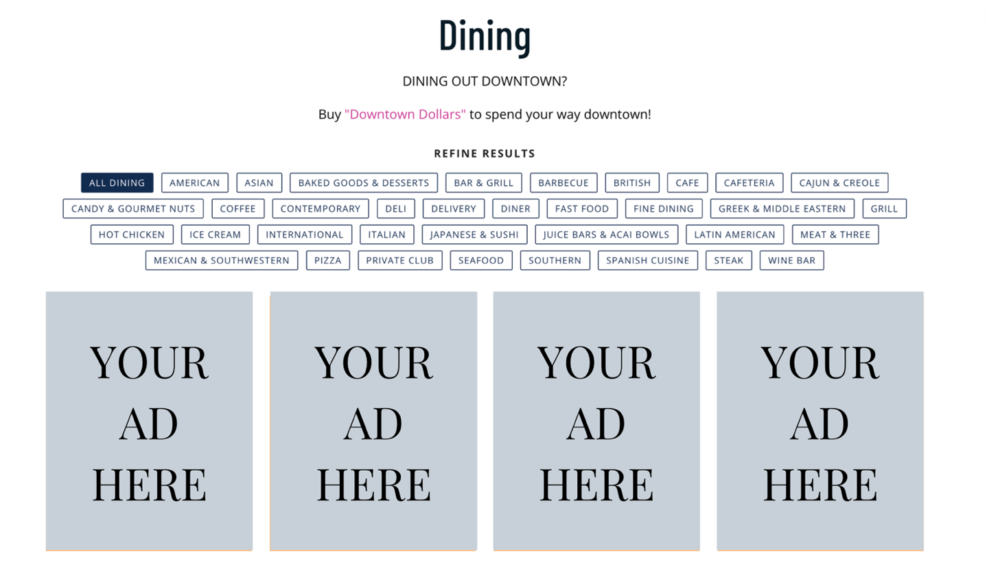

Guidebook Specs:
Full page ads: 3.25" wide x 8.25" tall, color
Half page ads: 3.25" wide x 4" tall, color
Inside front/back cover: 3.56" wide x 9" tall, color
Back cover: 3.81" wide x 7" tall, color
*File should be saved as pdf or jpeg files, 300 dpi

