CONSUMER & RETAIL
Small Business Saturday is coming: Deals include Virginia Beach scavenger hunt with winner-takes-all prize
By Tara Bozick and Trevor Metcalfe
The Virginian-Pilot • Nov 25, 2022 at 9:22 am

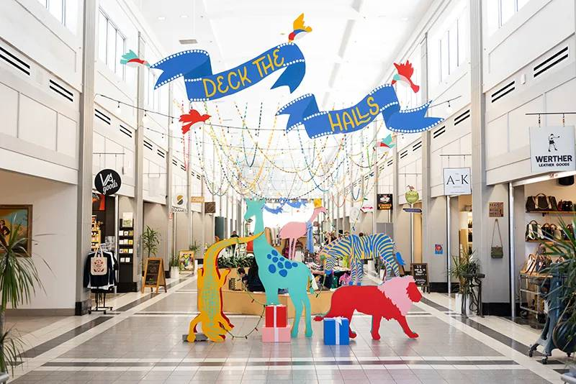
Selden Market in Norfolk is a hub for the city's Small Business Saturday events and will be open from 11 a.m. to 6 p.m. Saturday. (Courtesy of the Downtown Norfolk Council)
Hampton Roads retailers are joining efforts to grab attention away from the big-box chain stores during the holiday shopping season on Small Business Saturday.
More than 75 small businesses are offering specials, discounts and other promotions in the ViBe Creative District with a marketplace planned 10 a.m. to 4 p.m. in ViBe Park in Virginia Beach, said Kate Pittman, executive director of the ViBe nonprofit. A pop-up market with military-owned businesses runs 9 a.m. to 1 p.m. at 1701 Coworking at 1701 Baltic Ave.
In its seventh year, the event has grown into a local favorite, Pittman said, and includes a neighborhood scavenger hunt with a grand prize package worth more than $1,000 collected from participating businesses, she said. Shoppers grab a form at ViBe Park or download it from vibecreativedistrict.org, then visit 12 or more participating businesses and find answers to the form’s questions to enter a drawing. A winner, who takes all, is announced by Dec. 2.
“Oh my God, it’s wonderful. It’s our busiest day of the year,” said Carla Jernigan, owner of Gypsy Soul Boutique at 1707 Mediterranean Ave.
The ViBe’s Small Business Saturday event draws plenty of people, she said. Jernigan said she feels positive about how the shopping season will go as the local community strongly supports small businesses. The store sells unique apparel, accessories, gifts, jewelry and home décor, and Jernigan said she sources her items from local artisans and small businesses.
The neighborhood also welcomes businesses from outside Virginia Beach, Pittman said. Brick-and-mortar store owners are willing to help the smaller businesses reach a wider audience.
“That’s always a really cool thing to see, where businesses can actually pop up in a tent and establish a customer base and then grow,” Pittman said.
Lisa DeNoia, co-owner of Fathom Coffee and 1701, said her shop had great sales this year.
“I think we will have a great day on Saturday,” DeNoia said.
About 42% of 1,548 U.S. shoppers surveyed by LendingTree said they plan to shop on Small Business Saturday, a drop from 49% last year. They plan to spend an average of $271, down from $305 last year. LendingTree analyst Matt Schulz attributed the tighter spending to inflation reaching a 40-year high.
Of more than 50 Hampton Roads businesses surveyed by the Retail Alliance, 52% expect a slight growth in sales this holiday season and 20% expect the same as last year. Most of the surveyed small businesses said inflation has become their biggest concern, with a fear of an economic recession also on their minds, the nonprofit alliance reported.
Beyond spending money locally, DeNoia and Pittman said the public can support small businesses by bringing friends and family to Saturday events and spreading the word about locally owned retailers.
Small Business Saturday, founded by American Express in 2010 and co-sponsored by the Small Business Administration since 2011, is a holiday shopping day focused on independent retailers and small businesses. Participating businesses are listed at shopsmall.com.
The Downtown Norfolk Council is promoting the area’s independent retailers and restaurants. Selden Market at 208 E. Main St., is a “shop small” headquarters 11 a.m. to 6 p.m. with more than 50 small businesses, including pop-up vendors. The festively decorated market is hosting Santa noon-2 p.m., a gift wrap station 11 a.m. to 4 p.m., live entertainment and early shopper giveaways.
Other Saturday events featuring small businesses include:
- Small Business Saturday at Kitsch, 10 a.m. to 2 p.m., 1513 Colley Ave., Norfolk. The handmade and vintage boutique is hosting hot cocoa and discounts. Blair Family Woodcraft is raising funds through ornament sales for PFLAG Hampton Roads. Kimberly Ann Jones Art will be creating custom hand-lettered ornaments. Santa will be collecting donations for the food bank. Ashlimarierose Studio is creating silhouette portraits for people and pets from noon to 4 p.m.
- Small Business Saturday at COVA, 10 a.m. to 3 p.m., 9529 Shore Drive, Norfolk. COVA Brewing is hosting a market with local vendors and food trucks.
- Small Business Saturday Vintage Market, 2-7 p.m., Reaver NFK, 3800 Colley Ave., Norfolk. The brewery and Hanks Vintage are hosting a market for Small Business Saturday with various vintage vendors, along with discounts.
- Portsmouth Olde Towne Farmer’s Market, 10 a.m. to 2 p.m., Portsmouth Art & Cultural Center, 400 High St., Portsmouth. More than 50 vendors, free tarot card readings, free henna tattoos, live music.
- {Re}Stored Pop-Up Shop Event, 10 a.m. to 4 p.m., Bank and Main streets, downtown Suffolk. The city’s Economic Development Department is hosting a Small Business Saturday event with 30 merchants, discounts, holiday specials, coffee, hot chocolate, balloon artists, live entertainment, face painting and Santa. Courthouse Fountain Park will host a comfortable seating area with several large-screen TVs showing sporting events.
- Williamsburg Farmers Market, 8 a.m.-noon, 345 Duke of Gloucester St., Williamsburg. More than 40 vendors, live music and demonstrations.
- Carrollton Christmas Market, 10 a.m. to 3 p.m., Old Point Bank, 13480 Carrollton Blvd., Carrollton. More than 40 vendors, music, Christmas tree sale, food and Santa. Free. For more details, call 757-357-5182.

