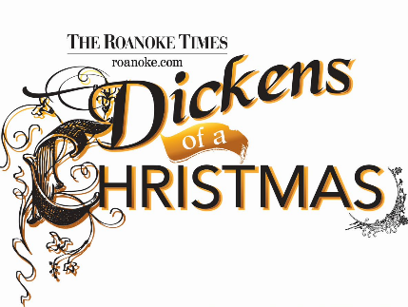
2022 Dickens of a Christmas Vendor Application
Deadline for Applications: November 4, 2022

Name: ____________________________________________________________
Address/City/St/Zip (Required): __________________________________________
Phone (Required): _________________Email (Required): ______________________
Identify each specific item to be sold: ___________________________________
__________________________________________________________________

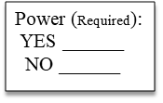
Craft Vendor
12/02/22________($110/Space)
12/09/22________($110/Space)
12/16/22________($110/Space)
All Three Nights________($275/Space)

Products/Services Vendor
Please make checks payable to DRI or pay by VISA or MASTERCARD
213 Market Street SE
Roanoke, VA 24011
540.342.2028
540.344.1452 (fax)

Contact: Tyler Mundy
540.342.2028 ext 14
tylerm@downtownroanoke.org
12/02/22________($175/Space)
12/09/22________($175/Space)
12/16/22________($175/Space)
All Three Nights________($450/Space)

Food Vendor
12/02/22________($220/Space)
12/09/22________($220/Space)
12/16/22________($220/Space)
All Three Nights________($550/Space)
Name on card: _____________________
Credit Card #: _____________________
Exp Date: _______ CVV# _________
Billing Address (If different from above)
________________________________
________________________________
Phone: __________________________
Signature: ________________________

**DRI reserves the right to approve all items sold at
this event. No more than two of any type of food
vendors as approved by DRI. All vendor spots are
10’ x 10’. Vendors are responsible for providing tents,
tables, drop cords, and all items necessary to conduct
business. No refunds will be given. **

