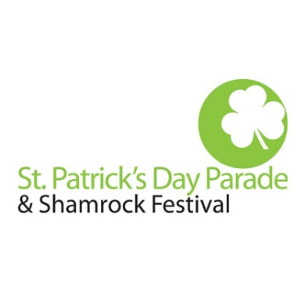

The annual St. Patrick’s Day Parade and Shamrock Festival will take place on Saturday, March 16, 2024. The event attracts thousands of people to downtown Roanoke for the day which will affect businesses around downtown.

The event will also result in downtown street closures. Jefferson St. from Walnut Ave. to Elm Ave. will be closed from 9:00AM-1:00PM due to parade lineup. Jefferson St. from Elm Ave. to Campbell Ave. will be closed from 10:30AM-1:00PM due to the parade. Campbell Ave., between 1st St. and Williamson Rd. will also be closed from 10:30AM-1:00PM for the parade. Once the parade has concluded, Jefferson and Campbell will open back up. The parking lot on Salem across from the Taubman (close to Williamson) will be accessible. The Center in the Square parking garage will be accessible before and after the parade.

The following streets will also be closed beginning at 7AM due to the Shamrock Festival and Celtic Celebration:
- Jefferson Street (between Campbell Avenue and Salem Avenue)
- Salem Avenue (between Jefferson Street and Williamson Road)
- Wall Street (west of City Market Building)
- Market Street (east of City Market Building)
- Market Street (between Norfolk Avenue and Salem Avenue)

All Streets should open back up by 6:00PM.

Thank you,

Tyler Mundy
Events Manager
Downtown Roanoke, Inc.
213 Market Street SE
Roanoke, VA 24011
540.342.2028 ext 14
tylerm@downtownroanoke.org

