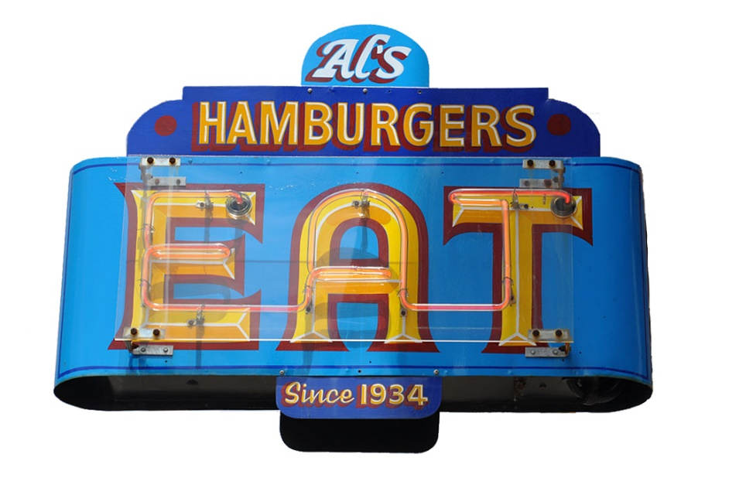

Al’s Special Events Menu

*Classic 1/4 lb Hamburger – Served with pickles & raw or fried onions $6
*Classic 1/2 lb. Hamburger – Served with pickles & raw or fried onions $8
Add cheese (American, cheddar, pepper jack, or Swiss) – Add .50

Hot Dog – Salmon’s all beef jumbo hot dog with raw onions & brown mustard $6
Chicken Strips – Breaded chicken breast filets served with BBQ, ranch or
honey mustard sauce $10

French Fries or Tater Tots $4
Cheese Curds – White cheddar $7
Soda – Pepsi, Diet Pepsi, Mountain Dew, Sierra Mist, Root Beer $3
Bottled Water $2
Ice Cream Sundae – With your choice of topping - Chocolate, vanilla, strawberry,
cherry, blueberry, caramel, butterscotch, or Oreo cookies $5

* Consumer Advisory: The management advises that eating raw or undercooked meat, poultry, or eggs poses a risk
to your health, especially the elderly, young children under the age of 4 and pregnant women.

